
DATA STRUCTURE
ASSIGNMENT 1

September 21, 2026
HASNAT GUL
FA25-BCS-030

LAB TASK 1
CODE

#include <iostream>
using namespace std;
int main() {
int var = 10;
// declare pointer and store address of var
int* ptr = &var;
// print value and address
cout << "Value of var: " << var << endl;
cout << "Address of var: " << &var << endl;
cout << "Value stored in pointer ptr: " << ptr << endl;
cout << "Value pointed to by ptr: " << *ptr << endl;
return 0;
}
OUTPUT

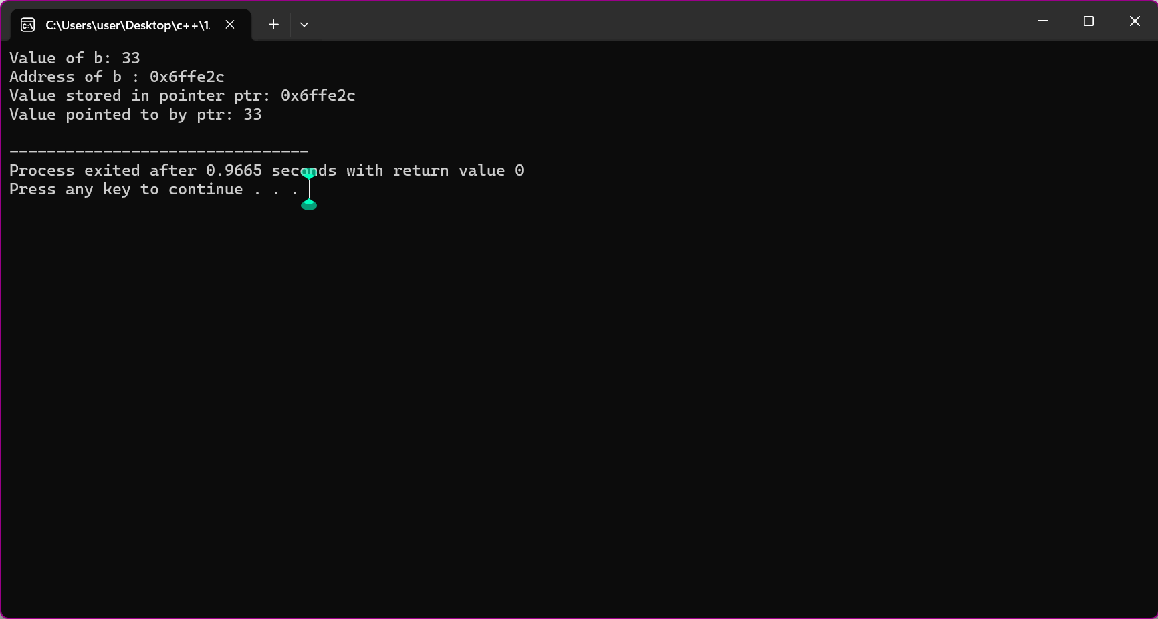
LAB TASK 2
CODE
#include <iostream>
using namespace std;

int main() {
int var = 10;

// Store the address of
// var variable
int* ptr = &var;

// Access value using (*)
// operator
cout << *ptr;
return 0;
}
OUTPUT
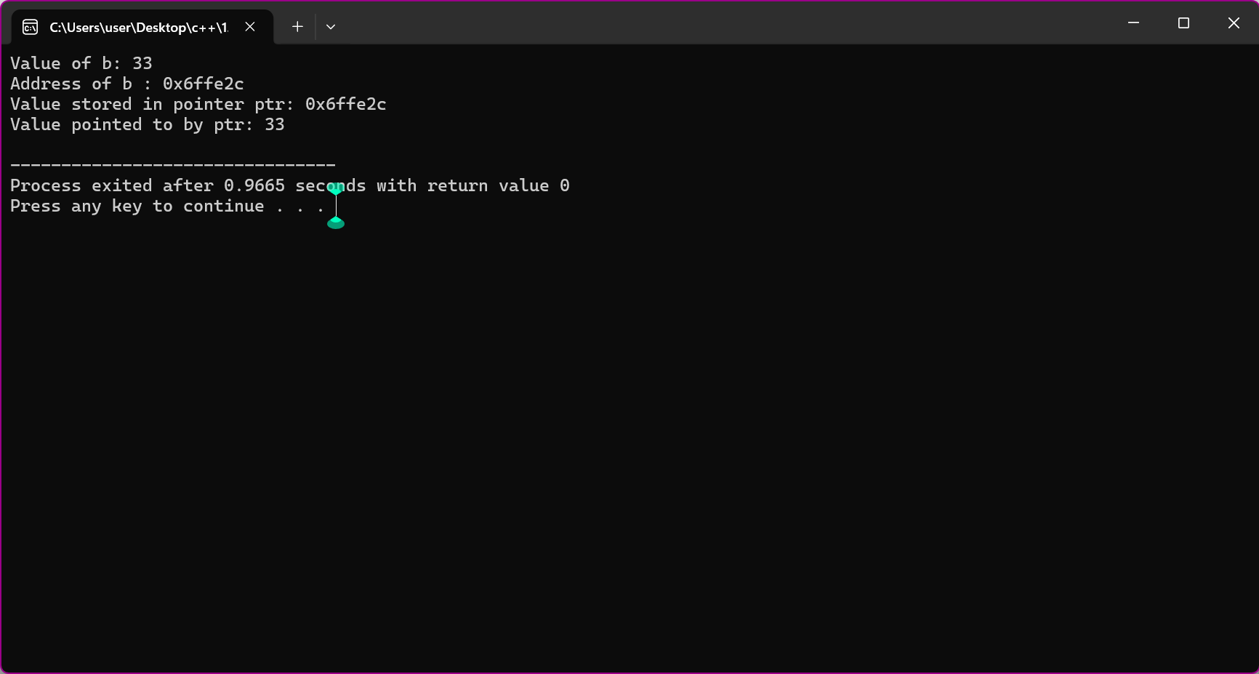
LAB TASK 3
#include <iostream>
using namespace std;

int main() {
int a = 10;
int b = 99;

int *ptr = &a;
cout << *ptr << endl;

// Changing the address stored
ptr = &b;
cout << *ptr;

return 0;
}
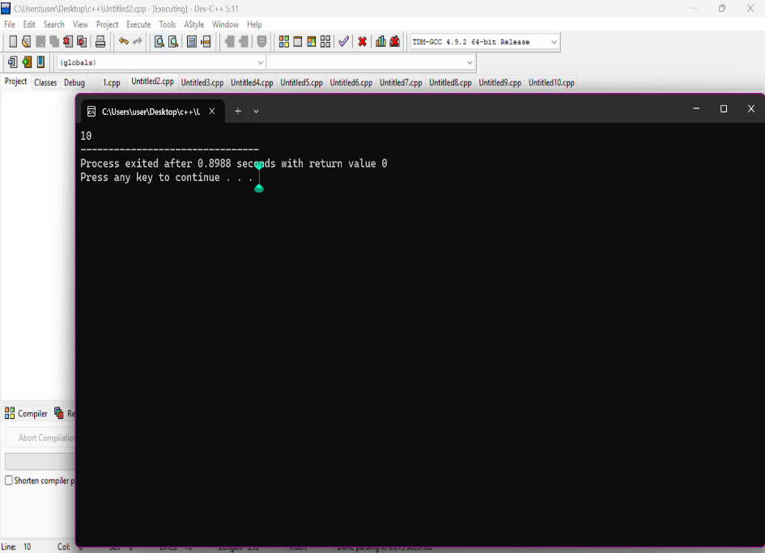
LAB TASK 4
#include <iostream>
using namespace std;

int main() {
int *ptr1;
char *ptr2;

// Finding size using sizeof()
cout << sizeof(ptr1) << endl;
cout << sizeof(ptr2);

return 0;
}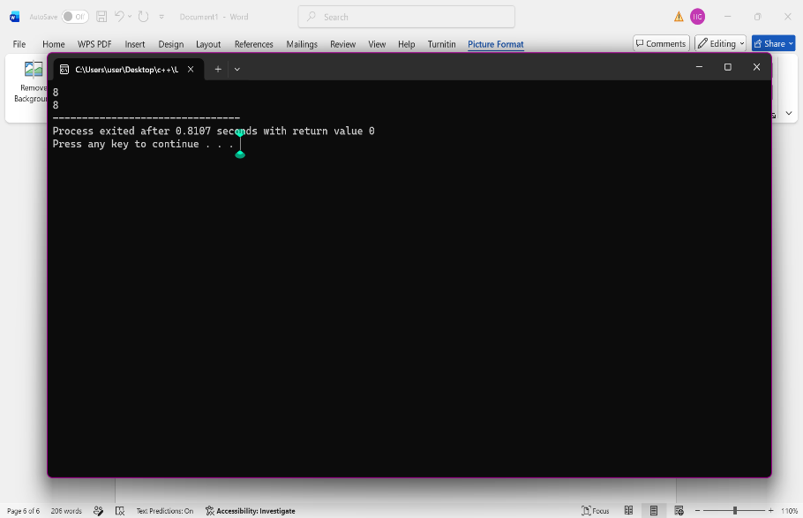
LAB TASK 5
#include<iostream>
using namespace std;
int main(){
int *ptr;
return 0;
}
LAB TASK 6
#include<iostream>
using namespace std;
int main(){
int var=10;
int* ptr1=&var;
int** ptr2=&ptr1;
cout<<*ptr1<<endl;
cout<<**ptr2;
return 0;
}
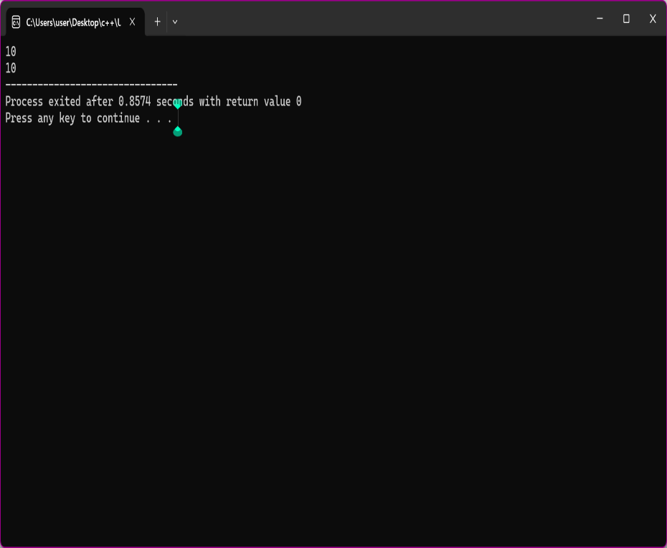
LAB TASK 6
#include <iostream>
using namespace std;
int* getPointer(){
int x=10;
return &x;
}
int main(){
int* ptr=getPointer ();
return 0;
}
LAB TASK 7
#include <iostream>
using namespace std;
int main(){
int x=42;
void*ptr=&x;
cout<<"value pointed by void pointer:"<<*(static_cast<int*>(ptr))<<endl;
return 0;
}
